

**CSE370**

**Database Systems**

**Spring-24**

**Lab Assignment - 1**

**Name: Faiaz Abrar Zaman Pronoy**

**Student ID: 22301061**

**Section: 13**

**TASK 1**

**BEFORE CREATING DATABASE:**

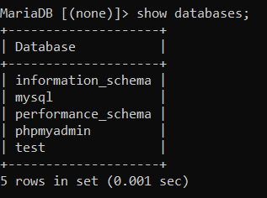

**DATABASE + TABLE CREATE:**

CREATE DATABASE 22301061_FAIAZ_PRONOY_LAB_01;

USE 22301061_FAIAZ_PRONOY_LAB_01;

CREATE TABLE Developers (

member_id int,

name varchar(30),

email varchar(30),

influence_count int,

Joining_date date,

multiplier int);

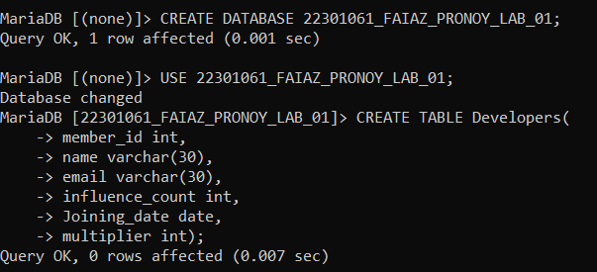

SHOW TABLES;

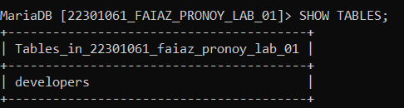

DESCRIBE Developers;

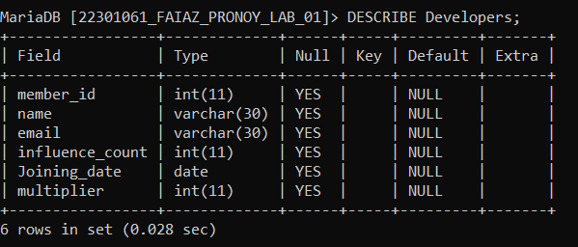

INSERT INTO Developers VALUES

(1, 'Taylor Otwell', '[otwell@laravel.com](mailto:otwell@laravel.com)', 739360, '2020-6-10', 10),

(2, 'Ryan Dahl', '[ryan@nodejs.org](mailto:ryan@nodejs.org)', 633632, '2020-04-22', 10),

(3, 'Brendan Eich', '[eich@javascript.com](mailto:eich@javascript.com)', 939570, '2020-05-07', 8),

(4, 'Evan You', 'you@vuejs.org', 982630, '2020-06-11', 7),

(5, 'Rasmus Lerdorf', 'lerdorf@php.net', 937927, '2020-06-3', 8),

(6, 'Guido van Rossum', '[guido@python.org](mailto:guido@python.org)', 968827, '2020-07-18', 19),

(7, 'Adrian Holovaty', 'adrian@djangoproject.com', 570724, '2020-05-07', 5),

(8, 'Simon Willison', '[simon@djangoproject.com](mailto:simon@djangoproject.com)', 864615, '2020-04-30', 4),

(9, 'James Gosling', 'james@java.com', 719491, '2020-05-18', 5),

(10, 'Rod Johnson', 'rod@spring.io', 601744, '2020-05-18', 7),

(11, 'Satoshi Nakamoto', 'nakamoto@blockchain.com', 630488, '2020-05-10', 10);

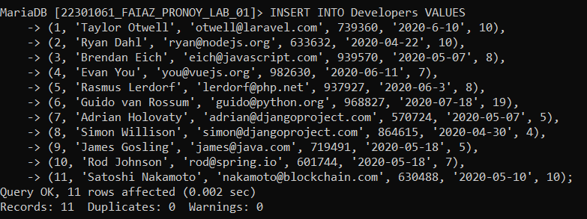

SELECT * FROM Developers;

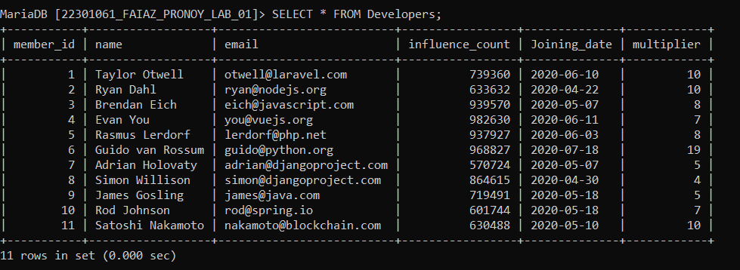

**TASK 2**

ALTER TABLE Developers CHANGE influence_count followers int not null;

SELECT * FROM Developers;

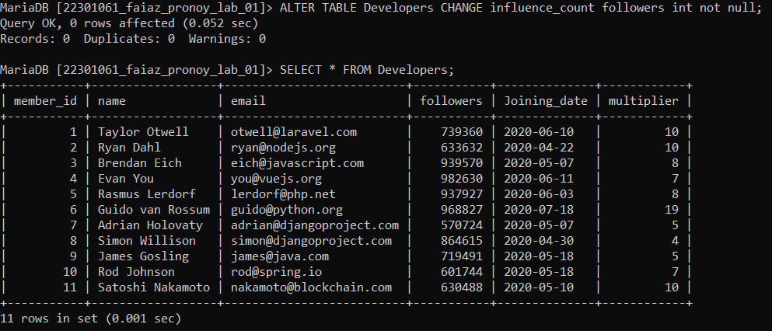

**TASK 3**

UPDATE Developers SET followers = followers + 10;

SELECT * FROM Developers;

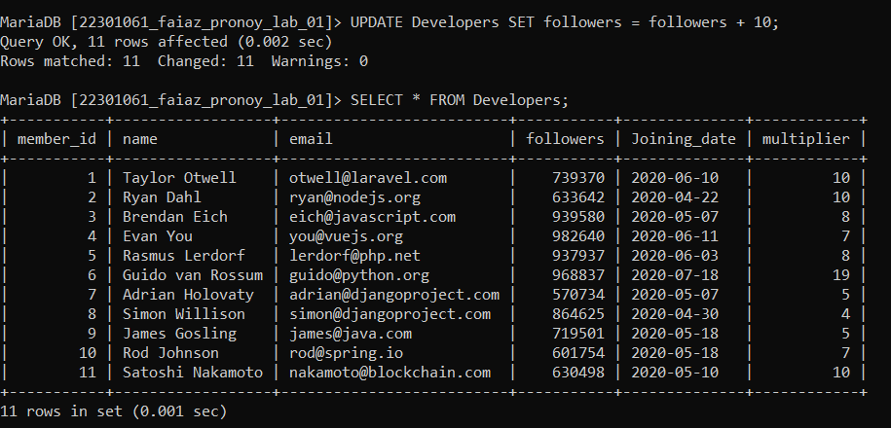

**TASK 4**

SELECT name, ((followers*100/1000000) * (multiplier*100/20))/100 AS Efficiency FROM Developers;

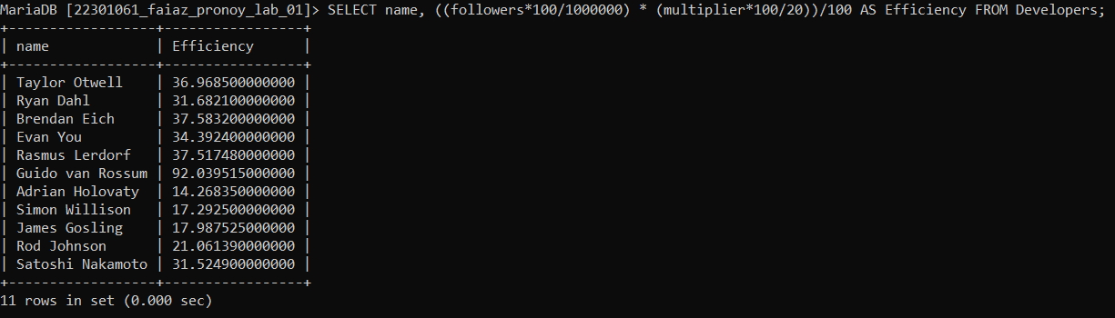

**TASK 5**

SELECT UPPER(name) AS Name, Joining_date FROM Developers ORDER BY Joining_date DESC;

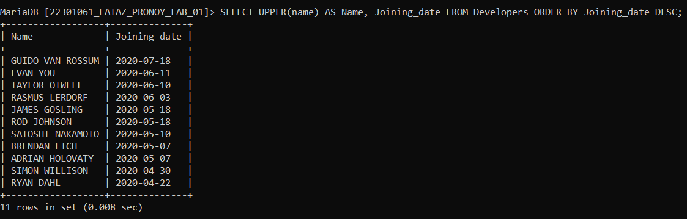

**TASK 6**

SELECT member_id, name, email, followers FROM Developers where email LIKE '%.com' or email LIKE '%.net';

